**FOOD ORDERING SYSTEM UML DIAGRAMS**

**GOWARAPPAGARI GANESH**

**{192011088}**

**1.USE CASE DIAGRAM**

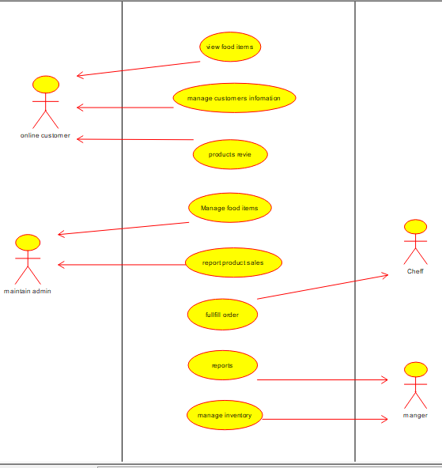

**2.SEQUENCE DIAGRAM**

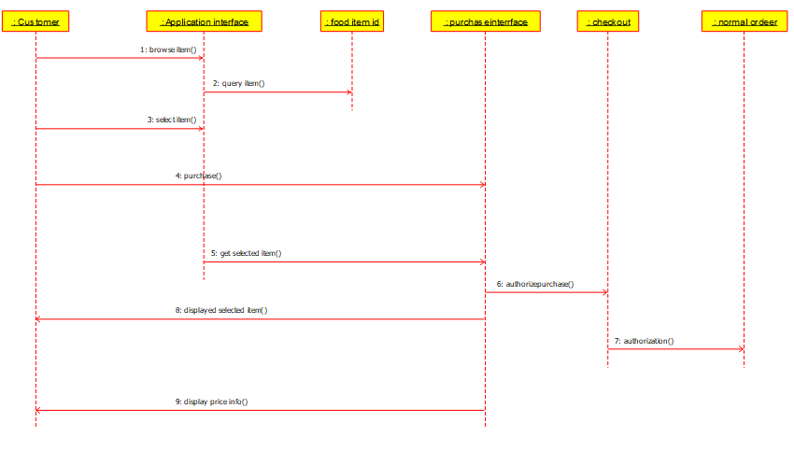

**3.CLASS DIAGRAM**

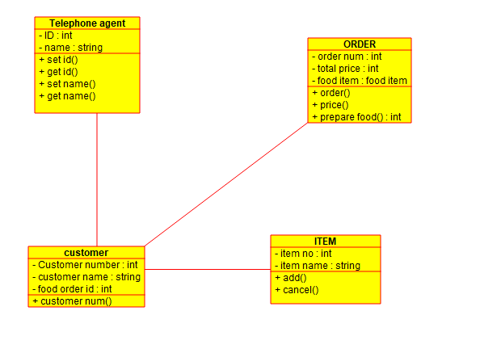

**4.STATE DIAGRAM / ACTIVITY DIAGRAM**

